LAB MANUAL 4
HOMEWORK
TAHA MUZAMMIL RASOOL
456279

TASK 1
#include <iostream>
using namespace std;
int main()
{
for (int x = 1; x <= 150; x++) {
if (x % 10 == 0) {
continue;
}
std::cout << x << " ";
}
}
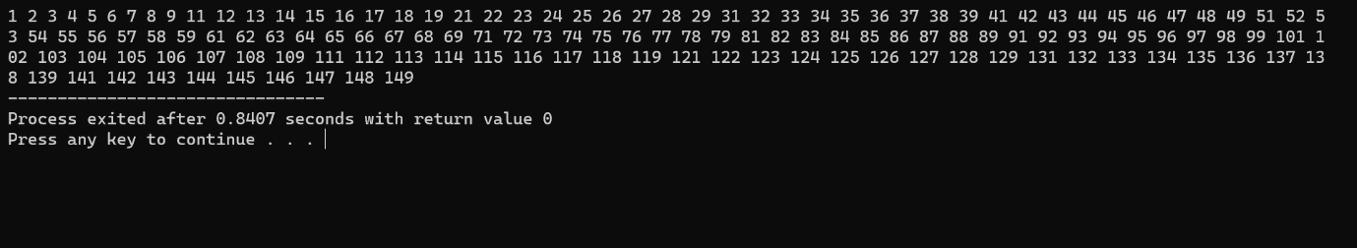

Task 2
#include <iostream>
using namespace std;
int main()
{
int x,y,z,sum;
sum = 0;
cout << "Enter a number: ";
cin >>x;
y=x;
while (y != 0) {
int z =y % 10;
sum+=z;
y/=10;
}
cout<< "Sum of digits of "<<x<< " is: " <<sum<<endl;
}
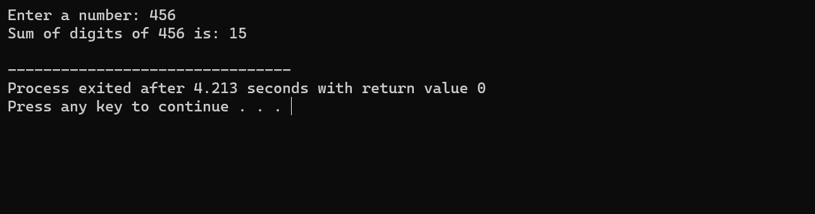

Task 3
#include <iostream>

bool isPrime(int number) {
if (number <= 1) {
return false;
}

for (int i = 2; i * i <= number; i++) {
if (number % i == 0) {
return false;
}
}

return true;
}

int main() {
int number;

std::cout << "Enter a number: ";
std::cin >> number;

if (isPrime(number)) {
std::cout << number << " is a prime number." << std::endl;
} else {
std::cout << number << " is not a prime number." << std::endl;
}
}
